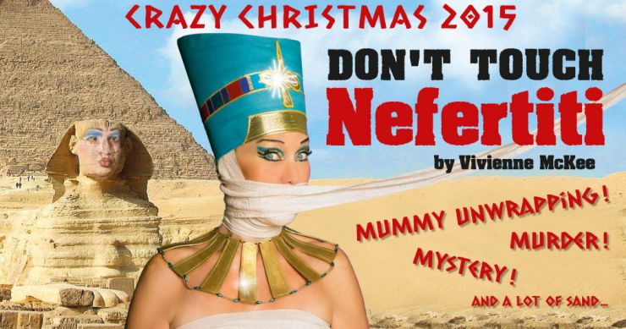

Content
Break Open the Secret Seals 4
- and Enter at Your Peril! 4
The Members of the Expedition 4
Picking apart the Pantomime 5
Before Entering the Gloom (Research and Quizzes) 5
Looking Over Your Shoulder (Talking Over the Show and Writing Reviews) 5
Nefertiti and the Heretic Pharaoh 7
Delving Deep for Prizes of the Past (Research) 7
Thank god(s) the European sahibs stol… saved our treasures from … well … us …?!? … Hang on! (Debating Exercise) 7
Publish or DIE! Mwahahaaaaa (Essay Writing) 10
Carter, Carnarvorn and the Curse of the Mummyeeeeeeeeeh………! (Research, Presentation and Grammar) 12
Out of the Tomb and into the Classroom 14
Crime/Detective Fiction 14
Horror Fiction 14
Comedy 14
The British Empire 14
The Arab Spring 15
Scroll for Translation 15

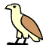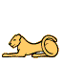

… or, in our plain unimaginative language, WELCOME! And YES that IS spelt with to chickens!

Where would we have been without the decrypting wonder of the Rosetta stone? And where will our archaeological expedition on stage be without the expedient Professor Rosetta Stone … Actually, where will they end up WITH Professor Rosetta Stone? Will she help them steer clear of cursed mummies and death on the Nile, or will Essex Jones, adventurer, have to get his whip out and save the day? Intrigued? Piqued? Enter into our Egyptian darkness and find out! We’ll carry a torch for you and lead you on through the mythological mysteries of ancient civilisations and less ancient would-be civilisers of Egypt in the 1930s.
As a seasoned explorer you will find no difficulties in keeping up, but your students may need a guide to fully appreciate a trip down the Nile with our fearless explorers.
Like any self- respecting pharaonic tomb, our teaching material offers many entries and exits to its secret interior:
- As an educational ante-chamber we open with a few exercises to gently ease your students into our maze of Egyptology. We focus mainly on our roots in the pantomime tradition, the story of Queen Nefertiti and the notoriously cursed archaeological expedition of Lord Carnarvorn and Howard Carter.

- We then offer various suggestions for successfully exiting our labyrinth and coupling Don’t Touch Nefertiti! with other teaching topics

- Both entries and exits are beset on all sides with various tasks including research, grammar, translation, writing and debating exercises to let your students acquire and prove their worth as aspiring Egyptological explorers.
So, don your white flannels, your pith helmet and your leather whip and be off!

Break Open the Secret Seals

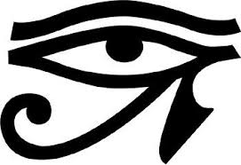
- and Enter at Your Peril!

Under the protection of the sacred Eye of Horus, we now embark on our quest! We’ll start by guiding you through the background research that have formed the basis of all sound scientific expeditions so far … as well as a few unsound ones.

The Members of the Expedition
Get to know the brave explorers you will be joining in the darkness. Ask your students to take a closer look at the names listed below – some of them you might want to read out loud... They’re not just any old names. Figure out what’s behind each one and discuss the comic effect .
- Howard Carter
- Professor Rosetta Stone (French/English egyptologist)
- Mustapha Falaffel (curator of the Cairo museum)
- Lord Albert George Herbert Carnarvorn (son of THE Lord Carnarvorn)
- Lady Hatshepsut Carnarvorn (Lord Carnarvorn Jr.’s mother)
- Cleopatra (Lady Carnarvorn’s sister)
- Professor Gunther Von Hinten (German archaeologist)
- Frances Golightly/Fanny (American actress and Lord Carnarvorn Jr.’s fiancé)
- Essex Jones (adventurer)
- Lotte Koch (grew up with Lord Carnarvorn Jr.)
- Dr. Van Helsingør
- Captain Haid D'Salaami
- Hercule Poirot

Also, a number of diggers, servants and the like will be peopling the stage. Oh … and of course THE MUMMY!!!!!!

Picking apart the Pantomime

Before Entering the Gloom (Research and Quizzes)
The dark roots of our dazzling display are to be found in the tradition of the British Pantomime. A basic understanding of its intricacies is a good guide through the maze of Queen McKee’s invention. To acquire that understanding, have all your students scroll through this bit of background:
http://www.its-behind-you.com/Factsheets/The%20History%20of%20Pantomime.pdf
Now divide your students into two groups:
- One group makes quizzes for the other group on either https://quizlet.com/ or http://socrative.com/
- The other group does whatever fascinating bit of grammar you are currently working on (or see suggestions for grammar exercises further down).
- They swap so the quiz makers do grammar while the others solve the quizzes.

You can either do this exercise in random halves, or you can differentiate so a small group of your top students have all the fascinating fun of creating the quizzes for the others to solve. Alternatively, divide them into groups on more or less the same level and let them make quizzes for each other. If you are pressed for time in class, you can also do it the simple way and just make a quiz yourself for the whole class. Both quiz making tools are very easily accessible, intuitive and simple.
But nothing about the Crazy Christmas Cabaret is ever simple – where would be the fun and craziness in that? Why follow a tradition when you can pick it apart and make your own unique creation? Have your students translate a few paragraphs from Pernille Nørregaard’s book Crazy Christmas Cabaret, hurrays og boos i 25 år (attached at the very end of this teaching material). In doing so, they can trace the path that the Crazy Christmas Cabaret has followed from traditional British panto to Copenhagen cult.

Looking Over Your Shoulder (Talking Over the Show and Writing Reviews)
Once your students have safely negotiated our nefarious narrative, have them consider the following questions:
- The Crazy Christmas Cabaret not only honours the proud traditions of pantomime. It also has traditions of its own such as Dr. Van Helsingør (you can call him Bent) and the phone call from Her Royal Highness Queen Margrethe II. The Doctor in particular is immensely popular, and devoted fans go to the show dressed as their Danglish idol. Discuss what it is about these two elements that appeals so strongly to a Danish audience.
- Where did Don’t Touch Nefertiti! depart from the traditions of the original panto?
- Why do you think Vivienne McKee has made these changes? Include your knowledge from the text you translated.
- Did Don’t Touch Nefertiti! live up to your expectations of a story dealing with explorers, mummies and ancient curses in colonial Egypt? Why/why not?
- Did you encounter any topical satire on your trip?

Have your students write a review of the show including a summary of the plot. If they can unravel and decrypt the strands of our twisted tale, they have truly proved their worth as adventurous archaeologists!

Nefertiti and the Heretic Pharaoh

Delving Deep for Prizes of the Past (Research)
Any aspiring Indi… Essex Jones, knows the importance of research. All the flirting with the bad guys and whipping the beautiful women ( … no wait, reverse that!) comes after careful study of the secrets you fight to unravel. To fully appreciate the story of Don’t Touch Nefertiti!, your students would do well to carry out some research on one or both of the following websites:
- http://www.biography.com/people/nefertiti-9421166#synopsis
This website has a video that takes you through the most important known facts about Queen Nefertiti and her Heretic Pharao

- http://www.history.com/topics/ancient-history/nefertiti
This website also covers the ground and then touches on the issue of Egyptian artefacts ending up in Europe which leads nicely to the formal debating exercise outlined below. The bust of the Queen is after all in Berlin – clearly a case where Indiana must have been busy elsewhere to have let the Germans in first! It also touches on the practice of incestuous marriages in the royal families of ancient Egypt.

Thank god(s) the European sahibs stol… saved our treasures from … well …
us …?!? … Hang on! (Debating Exercise)

Was the European practice of finders-keepers the only true approach to save archaeological treasures from withering away in badly managed and sparsely visited museums, from being stolen by locals or from simply being left to rot? Or was it just a hallowed kind of grave robbery that should now be amended by returning these treasures to their rightful owners as irreplaceable cultural artefacts essential to national identity? Use this ticklish question as a starting point for a debating exercise. Formal debate is an excellent teaching tool as it is applicable to almost any topic and can be used to deal with both non-fictional and fictional issues.
Now, be a true adventurer! Do not let yourself be daunted by the seeming complexity of the task. Any labyrinthine tomb is negotiable with a map, which is what we’re giving you here:
The setup of a formal debate involves eight people in the actual debate and then the audience who also get to participate. The underlined words are explained below.
- The chairperson:
The chairperson welcomes the audience to the debate, reads out the motion to be debated and introduces the teams before he/she sets the debate going. Before each speech, the chairperson introduces the speaker and generally runs the debate.

After the main speeches (first and second speakers of both teams), the chairperson opens the floor debate and asks the audience to pose questions or make comments. The chairperson chooses the people in the audience who get to speak. These questions and comments are not answered straight away but the summary speaker of each team takes notes and includes these questions and comments in their summaries.

After the floor debate the chairperson introduces the third/summary speakers. When the summary speakers are done, the chairperson asks the audience to vote and either pass or reject the motion.

It is advisable to let the teacher be chairperson the first couple of times.

- The timekeeper:
Each person gets three minutes to speak – no more, no less. During the first and last 30 seconds, the opposing team are not allowed to make points of information. The timekeeper marks each stage of the three minutes clearly for instance by knocking on the table.

The floor debate is given a set time limit by the chairperson depending on the groups of students and their level of activity.

The actual debate is between two teams of three:

- The proposition team who propose and defend the motion
- The opposition team who oppose the motion

Each team is divided into different speakers. All speakers have to give well-structured speeches with arguments and reasons that support their side. Part from the first proposition speaker, the speakers also have to think up rebuttals during the debate.

- First speaker:
The first proposition speaker is the first speaker of the entire debate who introduces the motion and then argues FOR this motion.
The first opposition speaker is the second speaker of the debate who argues AGAINST the motion

- Second speaker
The second proposition speaker is the third speaker of the debate who continues the argument FOR the motion
The second opposition speaker is the fourth speaker of the debate and continues the argument AGAINST the motion

- Third speaker or summary speaker
The third opposition speaker or the opposition summary speaker is the fifth speaker of the debate. After the floor debate, he/she sums up the entire debate in a way that argues AGAINST the motion.
The third proposition speaker or the proposition summary speaker is the sixth and last speaker and sums up the entire debate in a way that argues FOR the motion. PLEASE NOTE! The rhythm of the debate changes here because the proposition team always get the last word.

Thus the summary speakers cannot prepare their speeches in advance, but must base them on their notes from the debate. No points of information are allowed during the summary speeches.

Motion:
The subject of the debate. For instance: This house believes that private archaeologists should be given absolute freedom to explore, excavate and acquire artefacts across national boundaries.

Points of information:
Questions or challenging comments from one side to the other. After the first 30 seconds and for the following 2 minutes, the opposing team can ask questions that challenge the speaker currently making his/her point. The last 30 seconds of the 3 minute speeches are closed for points of information like the first 30 seconds.

You make a point of information by raising your hand and saying “Point of information.” The current speaker finishes their sentence and can then either say “Yes please” upon which the person with the point of information puts their question or challenging comment and receives an answer. They are then NOT allowed to continue asking. You only get ONE question/comment for each accepted point of information.

Alternatively, the current speaker can say “No thank you” and reject the point of information. There is no arguing with a rejection of a point of information.

There can be no points of information during the summary speeches.

Rebuttal:
A rebuttal is when a speaker responds to previous speeches from the opposing team or from the audience during the floor debate. Logically, the first proposition speaker does not have to make rebuttals, but all subsequent speakers do. This means they have to adjust the speech they have already prepared while listening to the opposing speaker to include rebuttals of points made in the opponent’s speech. This is why it is best to write speeches down in keyword form only. It makes it easier to adapt them with rebuttals and easier to present them with a natural flow.

Floor debate:
The floor debate is the part of the debate when the audience make comments or ask questions. It is not a true debate in itself since the speakers do not answer immediately. The answers are woven into the summary speeches.

Useful link: https://www.youtube.com/watch?v=EDTk-_Lt6sQ
This link is a short YouTube film where students illustrate the rules of formal debating with LEGO figures to the soundtrack of AXL F. What’s not to like? There are several more examples of debates following this pattern, go excavate for further treasures online.
When your students need to dig out material for their debate, a simple Google search on eg. “debate Egyptian artefacts” is usually a fruitful venture. Ever eager to please, we have singled out two useful links:
- http://debatewise.org/debates/204-historical-artefacts-should-be-repatriated-to-their-country-of-origin/
This links to a debating exercise on exactly this question of cultural artefacts being kept in Europe. It basically feeds arguments to your students ready organized in pros and cons. So as a fast lane to completing the exercise, it’s just perfect. Also, it has lots of other topics for debate that can be used in other connections.
- http://www.independent.co.uk/news/uk/this-britain/the-big-question-what-is-the-rosetta-stone-and-should-britain-return-it-to-egypt-1836610.html
This article outlines the question of ownership of historical artefacts nicely exemplified in the Rosetta stone. It is a good place to start.
We have now outlined the raw basics of a formal debate. There are several ways to refine and adapt this excellent exercise. If you are interested in more details and sophistications and maybe even in competing nationally and internationally, go to this website www.dodebate.dk. Through the courses offered here, you can learn much more, including the most effective ways to structure an argument or speech.

Publish or DIE! Mwahahaaaaa (Essay Writing)
We all know this mantra for any self-respecting scientist - including archaeologists. So practicing the art of well-structured writing is never amiss for all young Howard Carters to be. Also, scathing yet sophisticated criticism of the findings of lesser opponents is essential. Thus, we propose an essay writing exercise based on an article about Egyptian artefacts. It has the added bonus of letting your students practice the difficult art of writing essays about non-fiction texts and similarly allows them to flash their knowledge of article analysis (or alternatively, acquire one). We think bias and tone would make interesting focal points.
Link to the article: http://www.independent.co.uk/news/uk/this-britain/the-big-question-what-is-the-rosetta-stone-and-should-britain-return-it-to-egypt-1836610.html
Begin by dividing your students into groups of three – randomly or based on the level of their writing skills. Then:
- Have each student write an introduction to an essay about the article.
- The next step is that they swap intros in the group. Each student then writes a body text of 2-3 paragraphs for the introduction that their classmate wrote.
- Then, you ask them to swap a third time. They now have to write a conclusion for an introduction and body text written by the others in the group.
- The final step is to read through each essay and discuss its merits/give feedback.
You can either let them have what time they need for each step and keep the quick ones busy with grammar exercises and games online (see suggested links below). Or you can give them a set time within which to finish each step, thus practicing writing under pressure - very useful when you have evil Nazi archaeologists breathing down your neck to publish first!
Grammar links (a drop in the ocean, but such is the true nature of archaeology; a treasure may be a unique wonder or simply the bottom of a build-up of boundless booty):
- http://www.english-online.org.uk/games/gamezone2.htm
Games of various kinds including some fairly long adventure games such as The Grammar of Doom game which is quite in the right Indiana Jones / Lara Croft spirit
- http://www.grammar-quizzes.com/
Well … it has grammar quizzes, like it says
- http://www.sproglinks.dk/interaktiv_engelsk.htm
Quizzes and exercises on many levels
- http://freerice.com/#/english-grammar/1936309
Donates rice through the World Food Programme when you answer correctly!

Carter, Carnarvorn and the Curse of the Mummyeeeeeeeeeh………! (Research, Presentation and Grammar)
Why are people so scared of mummies? They are just dead people wrapped up in old bandages after all. For gods’ sake, they’ve had their brains removed through their noses; what’s left to fear? Well, there’s a story to that. A true one. Or is it? Have your students do some research on the finding of Tutankhamen’s tomb by Archaeologist Howard Carter and his financial benefactor Lord Carnarvorn in 1922. Chilling tales of mysterious deaths await!
Begin by doing some research online. Again, a simple Google search will get you far, but we have picked out a few choice sites:
- http://www.unmuseum.org/mummy.htm
Excellent site that deals with various mysteries of the world. It includes a short video about the concept of cursed Egyptian tombs. It is not as cheesy as it sounds. It has good references also from scientific and learning sources.
- http://www.theguardian.com/artanddesign/jonathanjonesblog/2014/jul/23/mummy-curse-legend-discovering-tutankhamun-ashmolean-museum
Good article about the story of Carter and Carnarvorn’s findings.
- http://www.ancientegyptonline.co.uk/tutcurse.html
A fairly short systematic look at the story of the curse
- http://ngm.nationalgeographic.com/2005/06/king-tut/mysteries/journey.html
and
http://archive.fieldmuseum.org/tut/explore.asp
Both these sites offer interactive/virtual tours of Tutankhamen’s tomb - might prove useful if some groups finish before others.

Have your students present their findings to each other. Here are some suggestions for forms of presentation. Some are well-known relics tried and trusted - done and dusted. Others less so.

- Ye olde PowerPoint Presentation/KeyNote/ePub
- Writing articles and sharing them in a magazine (practice those article analysis skills again)
- Making short films presenting the story as a thriller/news report/documentary etc.
- Making cartoons with http://stripgenerator.com/
- If you’re lucky enough to have that kind of class, why not choose a group to tell the tale as a ghost story with dimmed lights and candles? Chilling…!

You might also use the fascinating fiction (?) of the mummy’s curse as a basis for a creative grammar exercise:

- Choose the grammar topic of your preference.
- Divide your students into pairs and get them to write a short story about the curse of the mummy in which they include examples of as many of the rules related to the given grammar topic as possible. These rules have to be integrated fully into the story.
- Make them swap stories with another pair. They then have to decrypt the story and elicit the rules embedded in the narrative. If they are A-level STX students, have them write down the decrypted rules and explain them in the correct terminology.

You can use this as a summing up exercise for several grammar topics so that each story is about a different topic. When they moan, tell them that they will never become true adventure archaeologists before they master the art of decryption and encryption (you don’t want the evil Nazi archaeologists to read your secret messages do you?).

Out of the Tomb and into the Classroom
Don’t Touch Nefertiti! is an infusion of that aromatic romance that wafts through the streets of Cairo and beckons travellers to enter into mysterious places - and of sheer craziness of course. Whether you serve it up as an appetizer to get your topic going, a break in the middle, or a final flourish, our show can complement many different topics, and below you’ll find a couple of suggestions.

Crime/Detective Fiction
This year’s show is partially inspired by that Golden Age great, Death on the Nile. So, if you are teaching crime fiction and have the option of watching (or, in an ideal world, reading) Agatha Christie’s classic, you can let your students identify the elements in our show that hark back to this chilling tale of obsessive love and ruthless ambition floating down the Nile. It works equally well whether you see our show first or read or watch the original story first. You can do a similar thing with elements of detective fiction in general – get your class to identify what genre traits we have woven into our wild fabrication, whether the show is a starter for your topic or a nice, social summing up.

Horror Fiction
The curse of the mummy is a classic in horror fiction and Carnarvorn’s expedition is at the heart of it. As with detective fiction, you can work with a specific example of mummy horror fiction in direct relation to our show and let your students identify similarities and differences, or you can stay focused on genre traits. Also, you can work with the impact of comedy on horror and how these two elements complement each other in our show and in other examples of spoof or comic horror stories.

Comedy
Comedy as a topic in its own right opens numerous opportunities of incorporating Don’t Touch Nefertiti! - the names of the characters alone are enough to get you going. We suggest you get hold of the book Serious Business - Satire, Wit and Humour - from Shakespeare to Post-Modernism by Bo Høpfner Clausen and Jesper Kaalund. Together with a lot of good texts, it gives you an excellent toolbox of theory and terminology that the students can use for analysing comedy. This toolbox is also useful to have when dealing with other kinds of texts connected for other topics. There are very few texts that do not to some extent make use of for instance irony. Don’t Touch Nefertiti! offers ample opportunity to identify a true treasure trove of humorous devices and illustrates beautifully several theories about why we laugh.

The British Empire
Although Egypt is not very strongly represented in anthologies of colonial and postcolonial writing, the stereotype of the English lord exploring away at his leisure and carrying off important cultural artefacts is a well-known exponent of the British Empire. Thus, entangling yourselves in our enlightened darkness can be a fun way to see that stereotype illustrated and to set off a discussion; the debating exercise outlined above would be particularly useful in a topic about the British Empire.

The Arab Spring
And how will they link on to that? You ask yourselves. Well, the Arab Spring bubbles away anachronistically behind the action in Don’t Touch Nefertiti! . In teaching, the Arab Spring is a great topic that opens for cooperation with both social studies and religion. Whether they form part of such a joint venture or stand alone, English lessons can focus on analysing articles covering the events of the Arab Spring. You can also analyse and discuss the role of the social media and their particular fashion of communication in the revolution. Our show can, once again, set it off, break it off or finish it off.
Whichever approach you choose, we hope you have found this teaching material useful, and we look forward to tripping with you in the Egyptian darkness that will descend on Glassalen come November. May the Eye of Horus keep you safe!

Scroll for Translation
For the translation exercise outlined in the chapter about British pantomime, we proudly present a few paragraphs from Pernille Nørregaard’s book about our beloved show, Crazy Christmas Cabaret, hurrays og boos i 25 år. Please find these attached below.
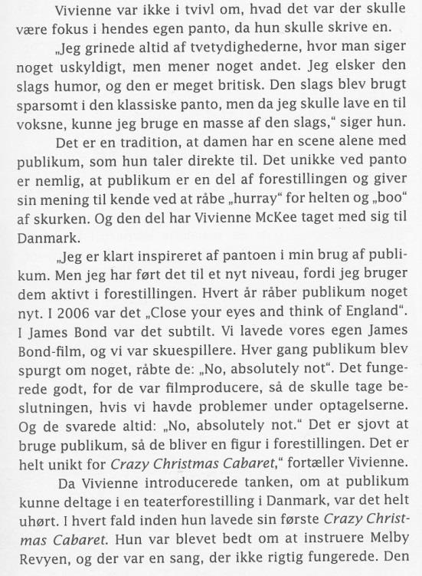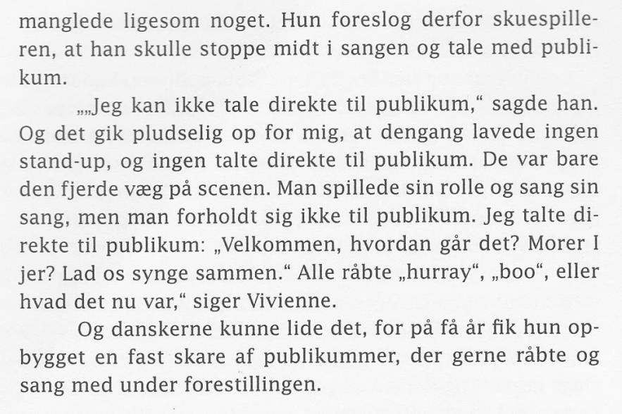
Nørregaard, Pernille. Crazy Christmas Cabaret, hurrays og boos I 25 år. Forlaget Documentas. Hellerup: 2007. 17-18.

